Software Requirement Specifications
E-Bike Rental System



Submitted by
Muhammad Tayyab

Submitted to
Ali Nawaz

Department of Information Technology
Faculty of Computing
The Islamia University of Bahawalpur

Summary
ConnectVibe is a web-based video sharing platform that allows users to upload, watch, and interact with videos. It provides essential features such as user registration, secure login, video uploading, and engagement options like likes and comments. Users can manage their profiles and explore content easily through a user-friendly interface.
The system also includes an admin panel that enables administrators to monitor and manage users and uploaded content. Built on a client-server architecture, ConnectVibe operates through standard web browsers and ensures performance, security, and reliability.
Overall, ConnectVibe offers a complete and efficient environment for video sharing and user interaction.

Table of Contents
1.1 Purpose 4
1.2 Scope 4
1.3 Product Perspective 5
1.4 User Characteristics 5
1.5 Similar Systems / Literature Review 6
1.6 Proposed Technologies 6
1.7 Definitions 6
2. Requirements 7
2.1 Functional Requirements 7
2.1.1 User Registration 7
2.1.2 User Login 7
2.1.3 Video Upload 7
2.1.4 Video Viewing 7
2.1.5 Video Interaction 7
2.1.6 Profile Management 8
2.1.7 Search Feature 8
2.1.8 Admin Control 8
2.2 Non-Functional Requirements 8
2.2.1 Performance 8
2.2.2 Security 8
2.2.3 Usability 8
2.2.4 Reliability 8
2.2.5 Scalability 9
2.2.6 Maintainability 9
3. System Design 9
3.1 Use Case Diagram 9
3.2 ER Diagram 9
3.3 Data Flow Diagram (DFD) 9
4. References 9

Introduction

1.1 Purpose
This document describes the requirements of the ConnectVibe system. It explains how the system will work, what features it will provide, and how users will interact with it.
The main goal of this document is to give a clear understanding of the system to developers and stakeholders so that the system can be developed correctly.

1.2 Scope
ConnectVibe is a web-based application that allows users to upload, watch, and interact with videos. Users can create accounts, upload their own content, and engage with other users through likes and comments.
The system also includes an admin panel where administrators can manage users, monitor content, and control system activities. This project mainly focuses on providing a simple and user-friendly video-sharing platform.

1.3 Product Perspective
ConnectVibe is an independent web application based on a client-server model. Users access the system through a browser, while the backend handles data processing and storage.
The system can later be extended with mobile applications or additional features, but currently it is limited to web usage.

1.4 User Characteristics
User
- Basic knowledge of using websites
- Can upload, watch, and interact with videos
- Needs simple and clear interface
Admin
- Moderate technical knowledge
- Responsible for managing system and users
- Uses admin panel for monitoring activities

1.5 Similar Systems / Literature Review
Many platforms such as video-sharing websites already exist globally. However, these platforms are complex and contain many advanced features.
ConnectVibe is designed as a simplified version focusing on core features like uploading, watching, and interacting with videos. This makes it suitable for learning purposes and small-scale implementation.

1.6 Proposed Technologies
Programming Language
- PHP / Python (depending on implementation)
Frontend
- HTML, CSS, JavaScript
Backend Framework
- Django / PHP-based framework
Database
- MySQL
These technologies are selected because they are easy to use and suitable for web-based applications.

1.7 Definitions
- User: A person who uses the system
- Admin: System manager
- Video: Uploaded media content
- Comment: User feedback on videos
- Like: User reaction to videos

2. Requirements

2.1 Functional Requirements

2.1.1 User Registration
The system shall allow users to create an account using basic details like name, email, and password.

2.1.2 User Login
The system shall allow registered users to log in securely.

2.1.3 Video Upload
Users shall be able to upload videos with title and description.

2.1.4 Video Viewing
Users shall be able to watch uploaded videos with playback controls.

2.1.5 Video Interaction
Users shall be able to like and comment on videos.

2.1.6 Profile Management
Users shall be able to update their profile and view their uploaded content.

2.1.7 Search Feature
Users shall be able to search videos using keywords.

2.1.8 Admin Control
Admin shall be able to manage users, videos, and system activities.

2.2 Non-Functional Requirements

2.2.1 Performance
The system should load pages quickly and handle multiple users at the same time.

2.2.2 Security
User data must be protected. Login authentication should be secure.

2.2.3 Usability
The interface should be simple and easy to use.

2.2.4 Reliability
The system should work without crashes and handle errors properly.

2.2.5 Scalability
The system should support future growth and additional features.

2.2.6 Maintainability
The system should be easy to update and maintain.

3. System Design

3.1 Use Case Diagram
The use case diagram represents how users and admins interact with the system. It includes actions such as login, upload video, watch video, and manage system.
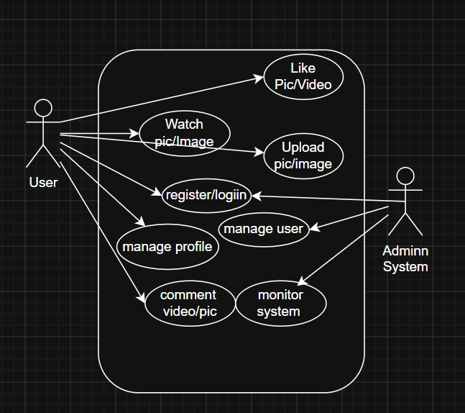

3.2 ER Diagram
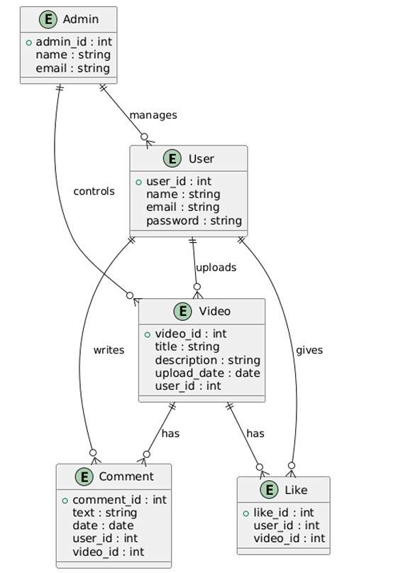ER diagram shows the relationship between different entities such as User, Video, Comment, and Admin. It explains how data is stored and connected.

3.3 Data Flow Diagram (DFD)
The DFD illustrates how data moves through the system. It shows how user input is processed and how results are generated.

4. References
- General concepts of web development
- Video sharing system design references
- Online documentation for selected technologies

